Lab 7: Projectile Motion

Group Submission
Madelyn Woodrow, Yoaneli Ortiz, Trung Vo, Patrick Ignaut, Marjory Cevallos

PHYS 1401
College Physics -1

2/17/2025

TABLE OF CONTENTS

Objective 3
Equipment 3
Theory and Equations 3
Procedure (Pendulum) 3
Data and Observations 4
Calculations 6
Results 7
Sources of Error 7
Discussion 8
Conclusion 8

OBJECTIVE:
The objective of this experiment is to predict and verify the range of a steel ball launched at varying angles.

EQUIPMENT:

Projectile Launcher | Meter stick x2 | White paper x4 | Carbon paper
Plumb bob | Steel ball (50g) | Angle indicator | Spirit level
Smart Phone | Tape | Pencil

THEORY AND EQUATIONS:
Anything thrown into the air and falling at an angle is called a projectile, which creates a parabola. For this lab, a steel ball will be launched at an angle with a Projectile Launcher at the top of the table. From this, the procedure will find and measure the distance that goes along the x-axes and y-axes. The initial velocity must be found before finding where the ball landed on the floor after being launched off the launcher. Then the ball is thrown, and the calculated number is compared to the position that was checked. It is believed that air friction is very small. Here is the equation of motion:
V_{xf} = V_{xi} + a_{x}(t_{f} - t_{i}) V_{yf} = V_{yi} + a_{y}(t_{f} - t_{i})
X_{f} = X_{i} + V_{xi}(t_{f} - t_{i}) + .5 a_{x}(t_{f} - t_{i})² y_{f} = y_{i} + V_{yi} (t_{f} - t_{i}) + .5 a_{y}(t_{f} - t_{i})²
V_{xf}² = V_{xi}² + 2a_{x} (x_{f} - x_{i}) V_{yf}² = v_{yi}² + 2a_{y} (y_{f} - y_{i})

PROCEDURE:
Part A: Determining the Initial Velocity of the Ball
- Secure the ballistic pendulum to the table, and move the pendulum out of the path of the ball.
- Measure the height Y from where the bottom of the ball would be in the Launcher to the ground by using a meter stick. Using the vertical height Y, calculate the time of flight and record it. This is the “Calculated Time of Flight” t.
- Fire the gun a few times to get an approximate position of where it strikes the ground, and then tape a piece of white paper and center it around where the ball lands. Cover it with a carbon paper (carbon side down).
- Use a plumb bob to find the point on the floor that is directly beneath the release point on the barrel. Measure the horizontal distance along the floor from the release point to the leading edge of the paper. Record information in a table.
- Shoot the ball at least five times and record the horizontal positions of each mark left on the paper. Measure the distance from the leading edge of the paper to each of the dots made where the ball hits the paper, and record these distances in the table.
- Find the average of the five distances and record in the table. Adding this to the distance from the leading edge of the paper gives the distance X.
- Using the average horizontal distance X and time of flight, calculate the initial velocity of the ball. Record in the table.
Part B: Measuring the Range of the Ball Launched at an Angle
- Adjust the angle of the Projectile Launcher to an angle anywhere between 30 and 60 degrees.
- Measure the vertical height from the ground to the launch point at the barrel, y_{i}. Using the initial velocity found in Part A of the experiment (V_{o}), the vertical distance (y_{i}) and launch angle (θ), calculate the time of flight to hit the floor. From the initial velocity and time of flight, calculate the horizontal distance x where the ball is expected to hit the ground. Record in a new table. This is the “Predicted Horizontal Range” x.
- Tape the white paper on the floor so that the predicted horizontal distance from the Projectile Launcher is near its middle. Cover the paper with carbon paper.
- Launch the ball five times. Measure the distances where the ball hits the ground and take the average. Record in the new table.
- Calculate the percent difference between the predicted (x) and measured values (X)
DATA AND OBSERVATIONS:
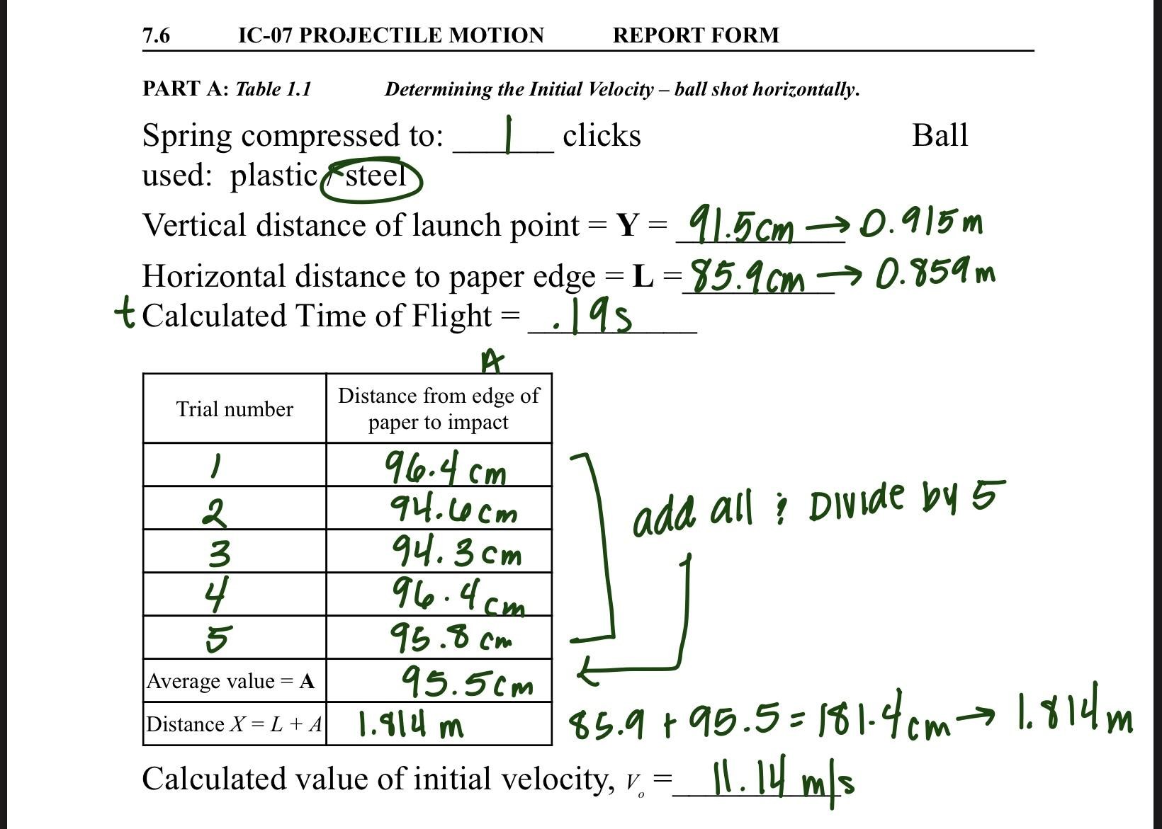
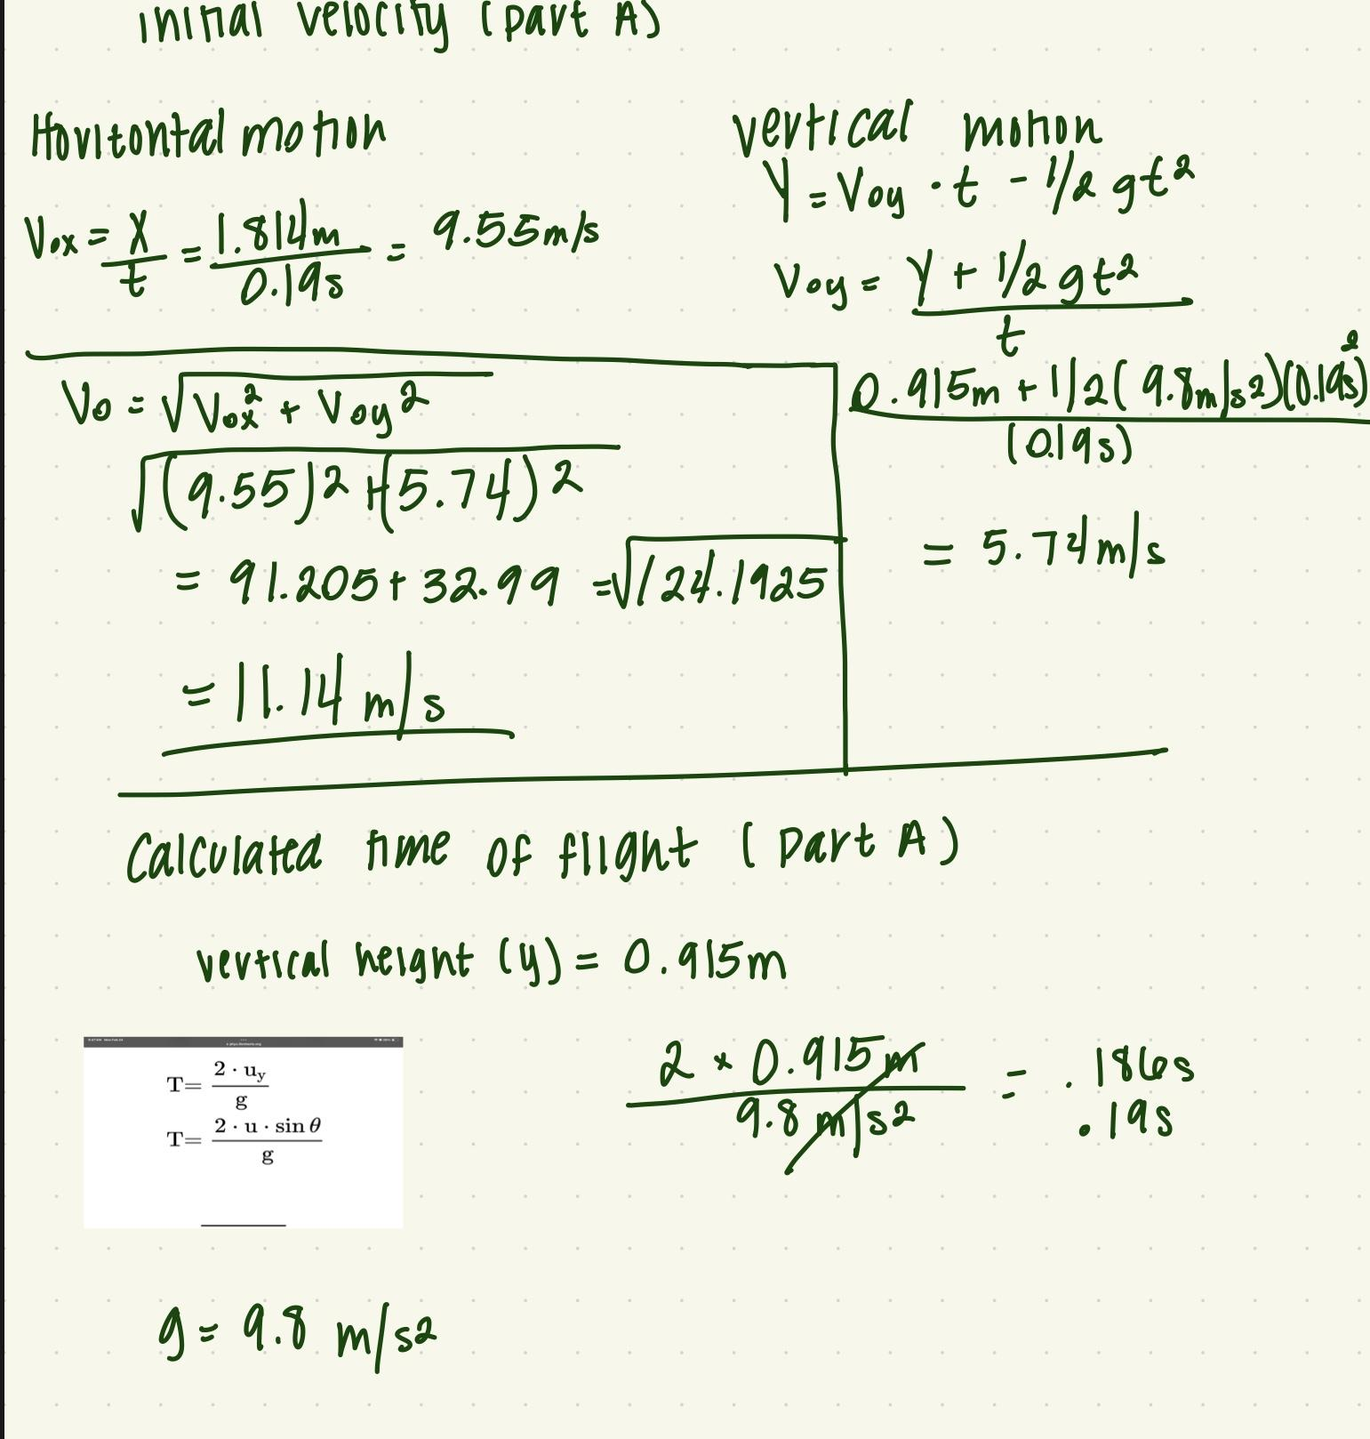

SOURCE OF ERROR:
- Measuring the maximum vertical height:
- The iron ball cannot be precisely measured at its highest point due to a lack of equipment. The results are not flawless when using the phone's slow-motion camera mode and two rulers hooked together.

CONCLUSIONS:
In conclusion, the experiment successfully demonstrated the principles of projectile motion by launching a steel ball from the Projectile Launcher and measuring its horizontal (x-axis) and vertical (y-axis) distances. By determining the initial velocity of the ball, we were able to predict the trajectory of the ball, which followed a parabolic path as expected. The measurements taken during the procedure allowed for a deeper understanding of how the horizontal and vertical components of motion influence the overall path of a projectile. This experiment reinforces the relationship between initial velocity, angle of launch, and the resulting displacement of a projectile in motion.

